@Date

@WithPrefixName

@WithoutCityAddress

@City

Dear @WithPrefixLastName:

This is to formally inform you that the check you issued with the following details (see below) returned due to @Reason DAIF (drawn against insufficient fund) @AccountNum Closed account.

|  |  |
| --- | --- |
| Name of Bank | @Bank |
| Check Number | @CheckN |
| Check Date | @CheckDate |
| Amount | @Amount |

We are sure that you realize the importance of maintaining a good credit standing with us and the legal consequences of issuance of unfunded check.

In view of this, we respectfully request you to personally visit the office **within five (5) working days** upon receipt of this letter to settle your amortization dues and avoid additional penalties and other charges.

Please disregard this letter if you have already updated your account.

Very truly yours,

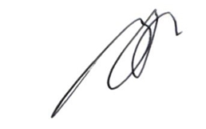

**ROGER O. ESCARO**

**Corporate Microfinance Head**